**What is the specific purpose of my speech?**

Not all human food can be eaten by stray cats. It is important to know if it can be eaten by stray cats before feeding it.（make it briefer by combining them into one statement）

**What is the audience for my speech? (Demographic traits: age / gender / cultural background / preference…)**

Mainly students in East China of Normal University

**In choosing a specific purpose, how do I narrow down the topic so it will be appropriate to my audience?**

There are stray cats in the school, many students tend to choose the food that is not good for them when feeding them, this is what happens around us, in the lives of audiences (good perspective)

**Situational audience analysis:**

**What is the size of audience**

A total of 38 people filled out the questionnaire

**What is their previous knowledge about the topic?**

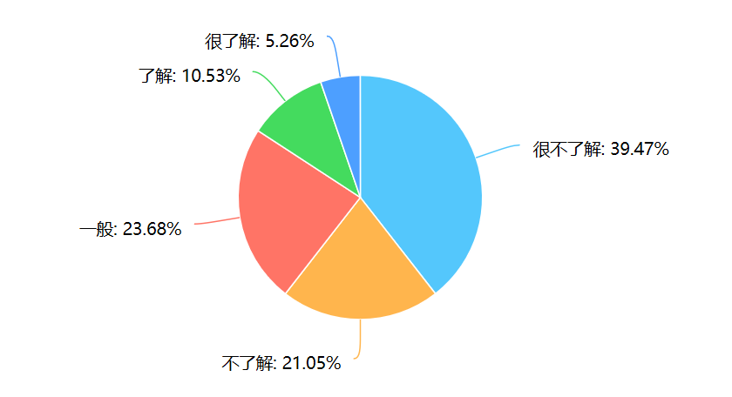

**What is their interest level in the topic?**

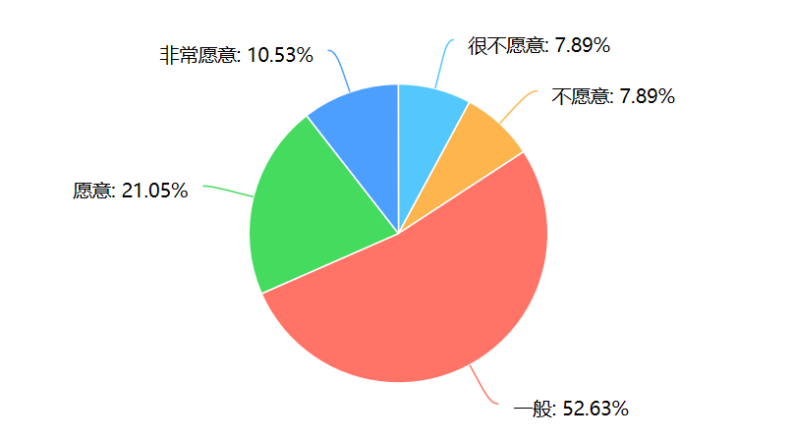

**What is their original attitude toward the topic?**

Six said it wasn't necessary, the rest agree.

**Other findings worthy of sharing / out of my expectation?**

Chocolate is poisonous to cats, and only one of the people who filled out the questionnaire chose to give it to the stray cats

Students who don't feel the need simply because they won't get a cat

**Adaptation to my audience**

**What devices do you plan to use in the introduction to gain attention from your audience?**

I'll show you pictures of cats that are sick from food, and I'll give you examples of people I've seen on campus feeding cats foods that are bad for them, and I'll give you a list of foods that we generally think are good for cats but bad for them. (pictures are good to arouse emotion, while statistics are needed for a more convincing speech. the data about the possible death/ illness caused by feeding the wrong food)

**Hou would you relate your topic to your audience in the introduction?**

Ask them what they would choose if they fed the stray cats, and use their answers to introduce the speech (their answer? Or their misunderstanding?)

**What are the possible main points of my speech? Why do I develop those points for my audience?**

Find out if it's ok to feed a stray cat. I have seen news that cats have been poisoned or affected by food poisoning in humans. I also found that many students in school did not know much about this, and they did not feed cats well. Our initial intention is good, but don't do evil with good intentions( Are you talking about it’s necessary to feed a stray cat or you need to know the proper way to feed a stray cat?) make sure you pick up a focus.

**What decisions do I make in choosing supporting materials for my audience?**

I choose to analyze whether the food that students often feed stray cats on campus is harmful to cats, and introduce healthy food that can be fed to stray cats

You need to arouse the interest from your audience since it is clear in your audience analysis that they don’t show much interest in this topic.